Sub phase-3 solution architecture
Date | 28-09-2026
Team ID | SWTID-2026-7624
Project name | Script – controlled ACL
Maximum mark | 4 mark

3. Solution Architecture
Solution architecture describes the major components of the Script-Controlled ACL system and how they interact with one another.
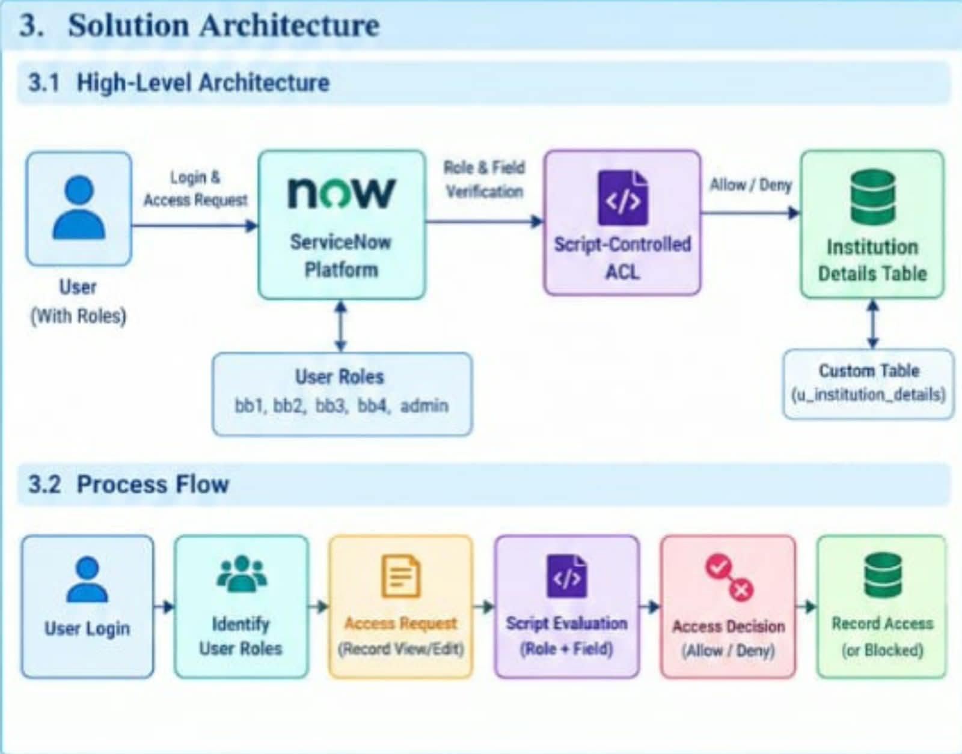
3.1 High-Level Architecture

The system consists of the following major components:

User

↓

ServiceNow Platform

↓

User & Role Management

↓

Script-Controlled ACL

↓

Access Decision

↓

Institution Details Table

The user sends an access request through ServiceNow. The system identifies the user's role and evaluates the ACL conditions. Based on the result, access is either granted or denied.

---

3.2 Architecture Components

Component| Description
User| Person requesting access to the system
ServiceNow Platform| Main application platform
User & Role Management| Maintains users and assigned roles
Script-Controlled ACL| Evaluates access conditions
ACL Rules| Define Read, Create, Write and Delete permissions
Institution Details| Custom table containing institution records
Database| Stores the application records
Administrator| Provides unrestricted access and manages the system

The Institution Details table is defined with fields including Student Roll Number, Student Name, Faculty Name, Branch, Email, Phone Number, and Description.

---

3.3 Process Flow

The complete system process is:

Step 1 – User Login

The user logs into the ServiceNow platform using valid credentials.

Step 2 – User Identification

The system identifies the logged-in user's roles.

Step 3 – Access Request

The user requests access to a record in the Institution Details table.

Step 4 – ACL Evaluation

The Script-Controlled ACL evaluates the user's role and the required field conditions.

Step 5 – Access Decision

The system determines whether the request should be allowed or denied.

Step 6 – Record Access

If the conditions are satisfied, the user is allowed to perform the permitted operation.

Step 7 – Access Denial

If the user does not satisfy the required conditions, access is denied.

Process Flow Diagram

User Login

↓

Identify User Role

↓

Access Request

↓

Script-Controlled ACL

↓

Role + Field Validation

↓

Access Decision

↙ ↘

ACCESS GRANTED ACCESS DENIED

↓

Institution Details Record

---

3.4 CRUD Access Architecture

The project separates the different database operations using custom roles.

Operation| Role| Purpose
Read| bb1| View permitted records
Create| bb2| Add new records
Write| bb3| Modify existing records
Delete| bb4| Remove records
Full Access| admin| Perform all operations

This design provides granular control over database operations.

---

3.5 Institution Details Table

The custom table used in the project is:

Table Label: Institution Details

Table Name: "u_institution_details"

Field Name| Field Type
Student Roll Number| Auto Number
Student Name| Reference
Faculty Name| Reference
Branch| Choice – ECE, EEE, CSE
Email| String
Phone Number| String
Description| Multi-Line String

---

3.6 Security Architecture

The security architecture ensures that users receive only the access permitted by their assigned roles and the defined record conditions.

Security Flow

User

↓

Authentication

↓

Role Identification

↓

Script-Controlled ACL

↓

Field Validation

↓

Access Decision

↓

Allow / Deny

The design also includes impersonation testing to verify whether users can see only the records permitted to them.

---

3.7 Expected Result

The expected result of the proposed architecture is:

1. Users with bb1 can view permitted EEE branch records.
2. Users with bb2 can create new records.
3. Users with bb3 can modify existing records.
4. Users with bb4 can delete records.
5. Users without the required roles are denied access.
6. Administrators can access all records.
7. Access decisions are dynamically controlled through ACL rules.

Conclusion
Phase-3 Project Design defines the complete design of the Script-Controlled ACL system. The design combines role-based permissions with field-based access conditions to provide controlled and granular record access.The architecture consists of users, ServiceNow, user roles, Script-Controlled ACLs, and the Institution Details database. By separating CRUD permissions and applying dynamic ACL evaluation, the proposed system provides a structured approach to secure record access.

